Documento de Base de Datos

SS- SUPERSHOP

**TEMPLATE REVISION HISTORY**

**Template Status (e.g. Draft, Final, Release #):**

| **Version** | **Date** | **Prepared By** | **Reviewed By** | **Approved By** | **Change Summary** |
| --- | --- | --- | --- | --- | --- |
| **1.0** | **23/05/2022** | **Apaza** | **Challanca** | **Challanca** |  |
|  |  |  |  |  |  |
|  |  |  |  |  |  |

**TABLE OF CONTENTS**

**Document Overview** **4**

**Introduction** **6**

**Database Objects** **8**

# **Document Overview**

* 1. **Document Revision History**

| Versión | Date | Prepared By | Reviewed By | Approved By | Change Summary |
| --- | --- | --- | --- | --- | --- |
| 1.0 | 23/01/2021 | Luis Apaza Gutierrez | Carlos Challanca Ccorupuna | Carlos Challanca Ccorupuna | Draft |
|  |  |  |  |  |  |

# **Introduction**

* 1. **Purpose of this document**

This document provides high level solution design information for application development and maintenance projects.

* 1. **Audience**

List project technical roles that are involved in applications delivery.

* 1. **Definitions and Abbreviations**

The following terms, acronyms and abbreviations are used in this document:

| Term/Acronym | Description |
| --- | --- |
| SS | Sigla que significa Yuri Montenegro Cliente y se usa para identificar al sistema contable integrado al CRM, este es un sistema capaz de “interactuar” con la persona que realizó la llamada a las funcionalidades que posee el CRM. |

* 1. **List of References**

The following documents and external information are referenced in this document:

| Item | Title | Author | Location |
| --- | --- | --- | --- |
|  |  |  |  |
|  |  |  |  |
|  |  |  |  |
|  |  |  |  |
|  |  |  |  |

# **Database Objects**

* 1. **Modelo Conceptual**

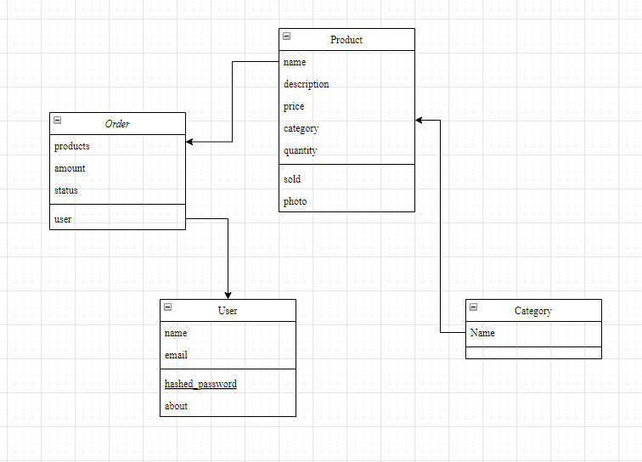

* 1. **Modelo Físico**
     1. **Detail Objects**
     2. **Tablas**

Nombre Tabla: USUARIO

| **CAMPO** | **TIPO DE DATO** | **OBLIGATORIO** | **VALOR POR DEFECTO** |
| --- | --- | --- | --- |
| name | String | si | null |
| email | String | si | null |
| hashed_password | String | si | null |
| about | String | no | null |
| salt | String | no | null |
| role | Number | no | 0 |
| history | Array | no | [] |

Nombre Tabla: Producto

| **CAMPO** | **TIPO DE DATO** | **OBLIGATORIO** | **VALOR POR DEFECTO** |
| --- | --- | --- | --- |
| name | String | si | null |
| description | String | si | null |
| price | Number | si | null |
| category | ObjectId | si | null |
| quantity | Number | no | null |
| sold | Number | no | 0 |
| photo | Buffer | no | null |
| shipping | Boolean | no | null |

Nombre Tabla: Categoría

| **CAMPO** | **TIPO DE DATO** | **OBLIGATORIO** | **VALOR POR DEFECTO** |
| --- | --- | --- | --- |
| name | String | si | null |

Nombre Tabla: Orden

| ***CAMPO*** | ***TIPO DE DATO*** | ***OBLIGATORIO*** | ***VALOR POR DEFECTO*** |
| --- | --- | --- | --- |
| *products* | *ObjectId* | *si* | *null* |
| *transaction_id* | *Object* | *si* | *null* |
| *amount* | *Number* | *si* | *null* |
| *address* | *String* | *no* | *null* |
| *status* | *String* | *no* | *Not processed* |
| *updated* | *Date* | *no* | *null* |
| *user* | *ObjectId* | *no* | *null* |